

Missing Children’s Network

To: Facility Managers Date: September 24, 2025
From: Walmart Foundation
Subject: Recovery Update and Maintenance of Missing Children’s Board

IMPORTANT NOTICE: PROCEDURE FOR RECEIVING

MISSING CHILDREN’S NETWORK PICTURES
Missing Children posters will be available on the WIRE by the first of every month. Ensure the posters are updated by the fifth of each month. If you have any questions, contact the Walmart Foundation Call Center at 1-800-530-9925.

Update: Congratulations! The number of missing children recoveries are growing each day. You and your associates play an important role in these recoveries by updating our Missing Children’s Boards each month.

Since January 1996 we have featured 21,228 children on our boards, with 19,169 recovered. To date, 286 children have been recovered as a direct result of the boards being in our stores.

- Remove and update posters and recovery count by the fifth of each month.
- Posters should be printed in color.
- REMEMBER: Only pictures sent directly from the Home Office can be posted. These pictures have been selected and approved by the National Center for Missing & Exploited Children. If you should receive a request to post a photo of a child that was not sent to you by the Home Office, please contact the Walmart Foundation Call Center at 1-800-530-9925 for assistance.
- Your Missing Children’s Board should look like the picture below.

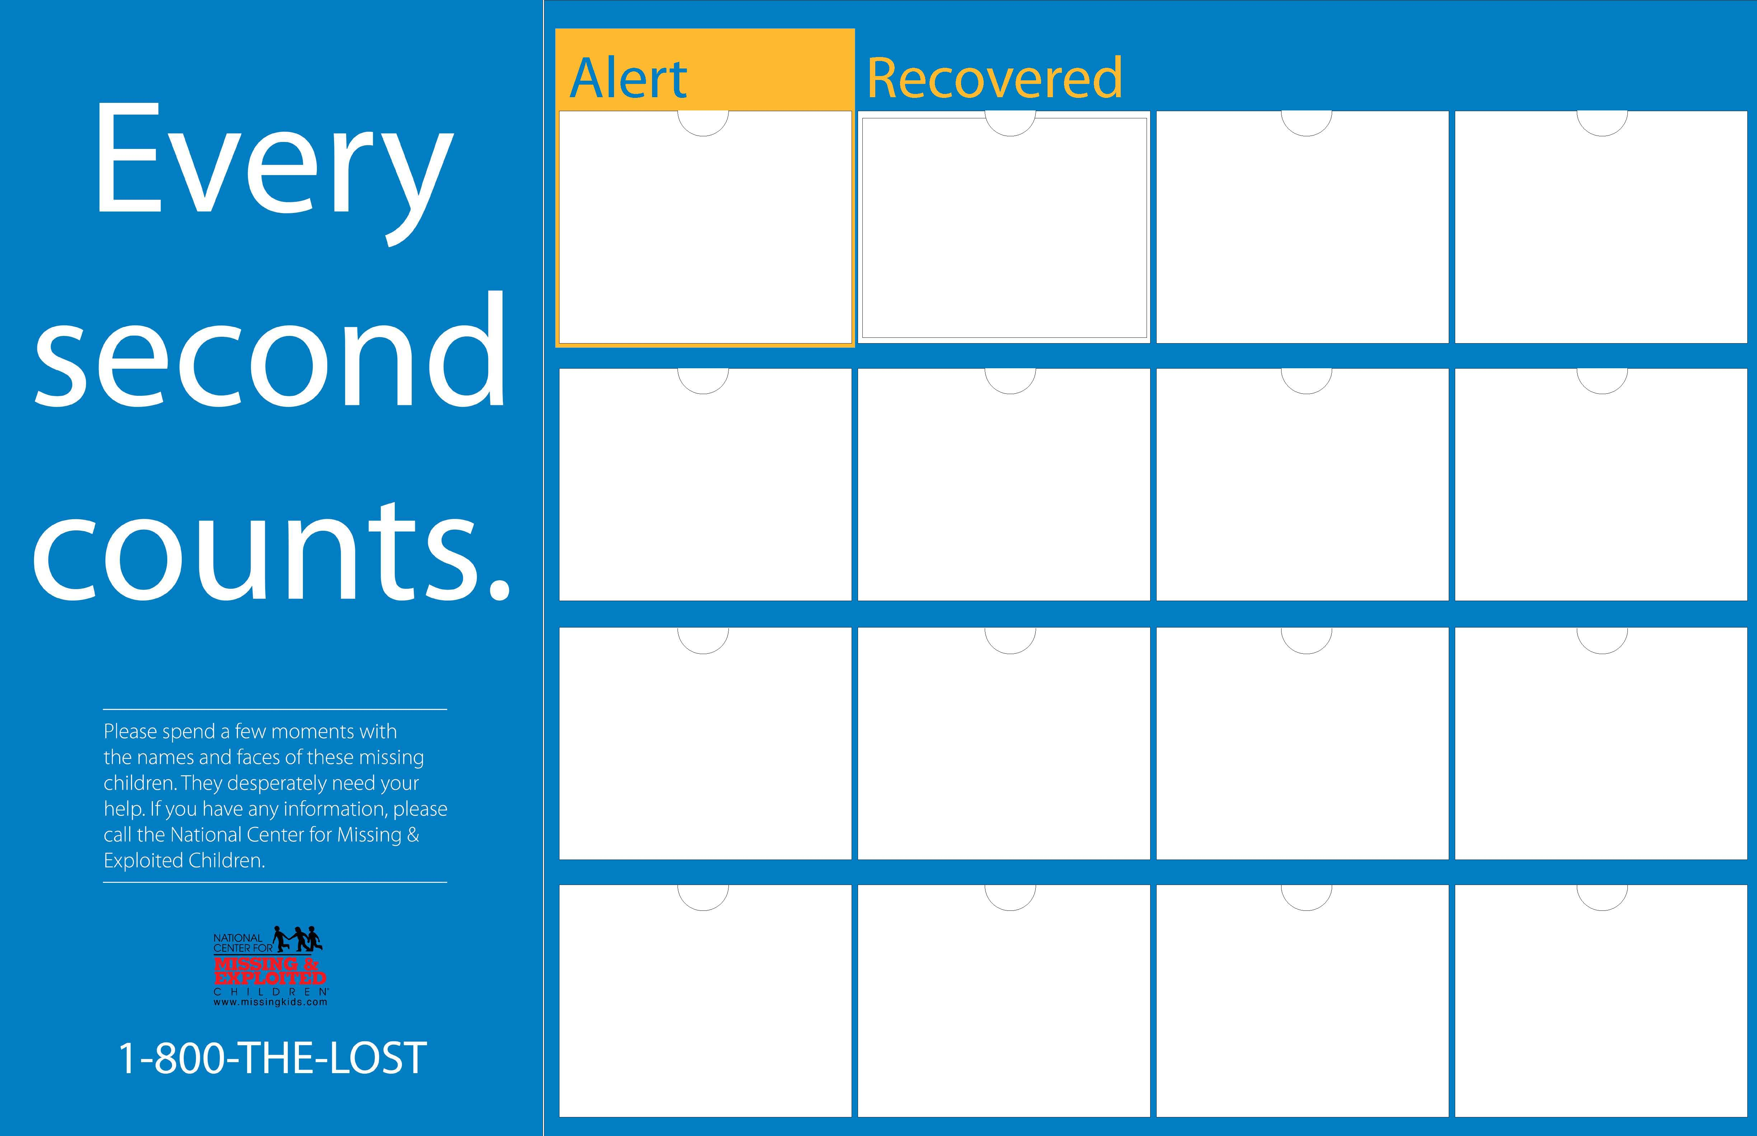

To order SIGNAGE only: Refer to item # 8865674
Divisions 1 & 7: Call the signing hotline at 1-700-925-6278.
Division 18: Email SCSIGN.
To order Missing Children's BOARD: Refer to item #MC-SCHED-BRD
Division 1 & 7: Order on the WIRE under Fixture Parts List
Division 18: Email SCSIGN

